Test deployment of our models.

Run application in terminal:

• **Endpoints**:

* GET /: Returns a message confirming that the model is ready to use.
* A screenshot of a computer

  Description automatically generatedA screenshot of a computer

  Description automatically generated
* POST /predict: Accepts JSON data for prediction and returns the model's prediction.

Check real data from our initial dataset in API application

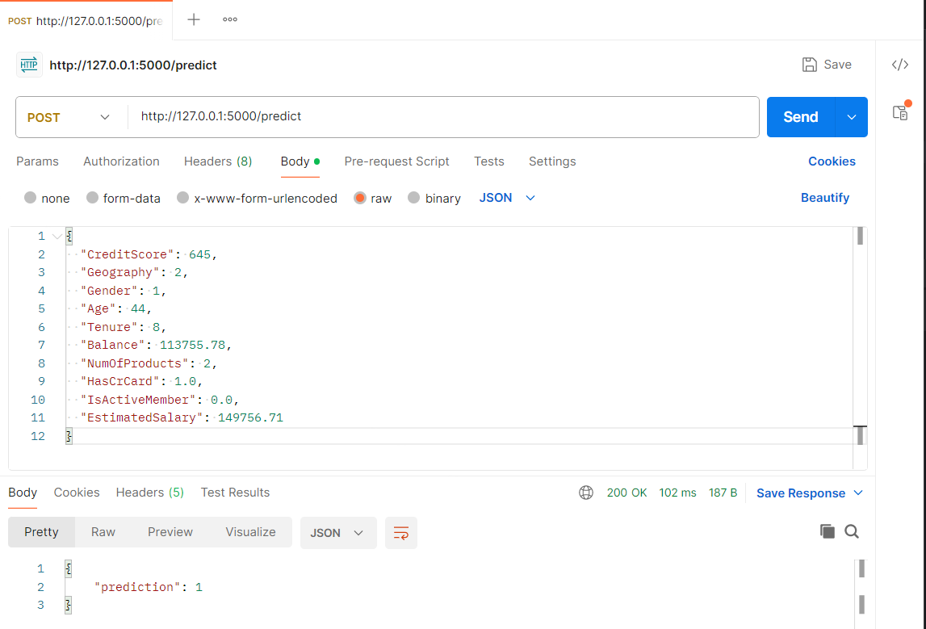

• **Error Handling**:

* Returns meaningful error messages if the input is missing or malformed.

After correction models name – work normal!

